Audens Col Trek

Auden's Col is a little known mountain pass that lies on the connecting ridge of Jogin I (6465 m) and Gangotri III (6580 m) at a height of around 5400m. It also connects the pilgrim centres of Gangotri and Kedarnath. It is named after J B Auden, a British Geographical Survey officer, who has first discovered this passage connecting Bhilangana Valley and Rudragaira Peak back in 1939. Auden's Col trek start from Gangotri Valley and ends at Kedar Valley. It is one of the challenging treks that mountaineers love to attempt while planning their adventure holidays.
Trekking to Auden's Col requires both skills and courage as this trek offers an unrivalled experience of the unsophisticated power of the nature. You need to be physically fit to undertake this trail as you need to walk on the glacial ice on this trek. Every year Auden's Col pass is crossed by adventurous trekkers from across the globe. This trek is the most adventurous pilgrims trek in the Garhwal region.
At trekking in India, we offer an exclusive Auden's Col Trek tour package that will take you to the real world of adventure. We ensure to offer a comfortable journey with our expert tour guide who has prior experience of trekking on this trail. Explore the natural beauty of this trek with us and become a part of our tour group. The best time to undertake this trek is June to mid Oct.
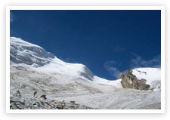
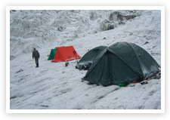
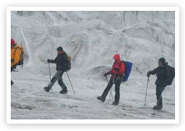
Duration : 20 Days
Grade : Tough
Auden's Col an Introduction Col is a mountain pass which connects Jogin I (6465m) and Gangotri III (6580m) peaks and is reportedly situated at a height of around 5400m. It also binds two glaciers on the opposite sides. One is Khatling glacier and the other one looks like the glacier belonging to Jogin I. Auden's Col is approachable from Gangotri and one can trek up to Kedarnath following Auden's Col and Khatling glacier. Auden's Col gets its name from J B Auden, who first crossed it in 1939-40.
Day 01: Arrive Delhi
Day 02: Delhi – Rishikesh
Day 03: Rishikesh – Uttarkashi
Day 04: Uttarkashi – Gangotri
Day 05: Gangotri – Bhojwassa (Acclimatisation trek)
Day 06: Bhojwassa – Gomukh – Tapovan (Acclimatisation trek)
Day 07: Tapovan – Bhojwassa – Gangotri (Acclimatisation trek)
Day 08: Gangotri - Nala Camp
Day 09: Nala Camp - Rudugaira BC
Day 10: Rudugaira BC - Rest day and acclimatization
Day 11: Rudugaira BC – Col BC
Day 12: Col BC - Khatling Glacier
Day 13: Glacier Camp - Waterfall Camp
Day 14: Waterfall Camp - Chowki
Day 15: Chowki - Kharsoli
Day 16: Kharsoli - Gangi
Day 17: Gangi - Ghuttu
Day 18: Ghuttu - Haridwar By vehicle
Day 19: Haridwar - Delhi By vehicle
Day 20: Delhi Departure

